Duns and District u3a
Committee Nomination Form
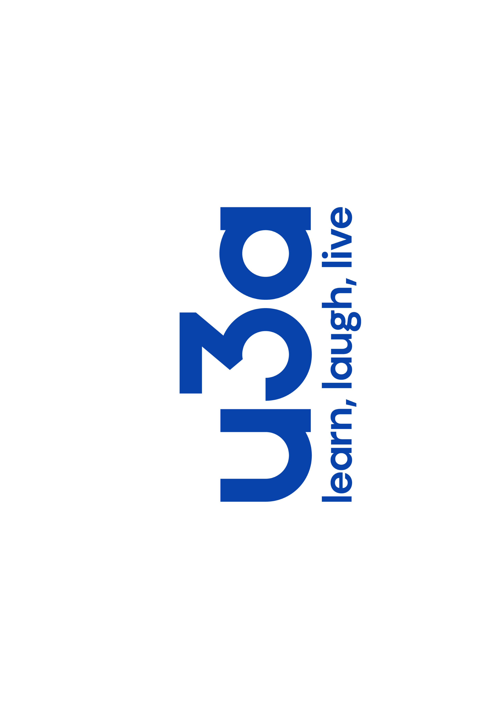
All positions on the committee are open for members to be nominated for the year 2021-2022. Candidates must be nominated and seconded by members of Duns and District u3a. Nominations should be returned to The Secretary, Duns and District u3a, Volunteer Hall, Langtongate, Duns, TD11 3AF
or by email to: dsquareddeb1@talktalk.net

The constitution allows for the following Officers: Chair, 2 Vice Chairs, Secretary and Treasurer. They form the 'Executive Committee'. Only the Treasurer can serve 2 consecutive terms and our serving Treasurer has intimated that he is willing to serve a further term.

Non- officers of the Committee are responsible for: Membership, Group Coordination, Monthly Meetings and Speakers, Venues and Communication.

We are seeking new members of the Committee who will work with existing members to help organise and manage our u3a and to bring fresh ideas and enthusiasm to the team.

Nominee:
Name:
I confirm that I am willing to be nominated for a position for the year 2021-2022. I give my consent for information on this form to be held by Duns and District u3a and consent to receive communications in accordance with the Data Protection and Privacy Policies.

Signature: Date:

Proposer:
I give my consent for information on this form to be held by Duns and District u3a and consent to receive communications in accordance with the Data Protection and Privacy Policies.

Name:
Signature: Date:

Seconder:
I give my consent for information on this form to be held by Duns and District u3a and consent to receive communications in accordance with the Data Protection and Privacy Policies.

Name:
Signature: Date:

